Spotify Listening Behaviour Analysis Report

Data Analysis Report

Author: Mohammad Abdulhafeez
November 24, 2025

Introduction
This project provides a comprehensive analysis of personal Spotify listening behaviour using Power BI. The insights were generated from a dataset containing track information, playtime duration, skip patterns, album engagement, device usage, and shuffle counts.
The goal was to transform raw listening data into a visually engaging and analytically meaningful dashboard, capable of revealing trends in music preferences, consumption habits, and platform usage routines.
This project demonstrates the ability to:
- Clean and model data
- Use DAX to compute meaningful metrics
- Build intuitive visualizations
- Derive insights from behavioural analytics
- Present findings in a professional, business-ready format

Overview of Dashboard Metrics

The dashboard focuses on six primary areas of music interaction:
- Total Playtime and Total Minutes Played
- Top Artists Based on Playtime
- Tracks Most Frequently Skipped
- Albums Most Played and Most Shuffled
- Skip Counts by Album
- Listening Distribution by Device/Platform
Across the dataset, the dashboard reports a total historical playtime of 19 billion milliseconds, converted to 320,000 minutes captured within the reporting period, and a shuffle count of 149,860.
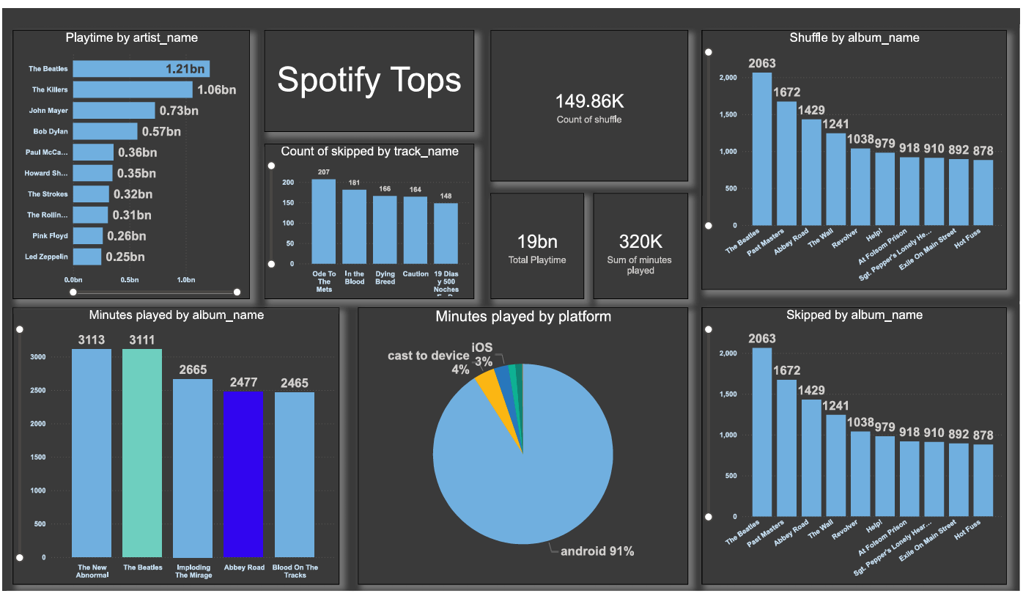
Key Insights (Dashboard Component)
Artist Listening Dominance
The dashboard reveals a strong and consistent preference for classic rock and alternative rock artists.
The top 10 artists by playtime are:
- The Beatles – 1.21bn milliseconds
- The Killers – 1.06bn milliseconds
- John Mayer – 0.73bn milliseconds
- Bob Dylan – 0.57bn milliseconds
- Paul McCartney – 0.36bn milliseconds
- Howard Shore – 0.35bn milliseconds
- The Strokes – 0.32bn milliseconds
- The Rolling Stones – 0.31bn milliseconds
- Pink Floyd – 0.26bn milliseconds
- Led Zeppelin – 0.25bn milliseconds
Insight:
Musical preference is highly skewed towards genre-defining, timeless artists mainly from rock, alternative, and legendary discographies. This suggests the listener values artist catalogues with depth, musical complexity, and longevity.
Track Skip Behaviour
The “Count of Skipped Tracks” report shows the following tracks as the most skipped:
- Ode to the Mets – 207 skips
- In the Blood – 181 skips
- Dying Breed – 166
- Caution – 164
- 19 Días y 500 Noches – 148
Insight:
These tracks are not necessarily disliked; in fact, several belong to frequently played albums. They appear more in skip statistics because the listener plays these albums often, and skips occur when restarting, navigating, or skipping intros.

Album Shuffle Behaviour
Albums with the highest shuffle counts include:
- The Beatles – 2063 shuffles
- Abbey Road – 1672 shuffles
- The Wall – 1429 shuffles
- Revolver – 1241 shuffles
- Help! – 1038 shuffles
Insight:
]Frequent shuffling of Beatles albums indicates a flexible listening pattern—exploring multiple tracks within albums rather than following a fixed sequence.

Minutes Played Across Albums
The top albums with the highest minutes played are:
- The New Abnormal – 3113 minutes
- The Beatles – 3111 minutes
- Imploding the Mirage – 2665 minutes
- Abbey Road – 2477 minutes
- Blood on the Tracks – 2465 minutes
Insight:
The listener tends to enjoy full album experiences, not just trending singles. Albums from The Strokes, The Beatles, John Mayer, and Dylan feature prominently, showing a preference for cohesive storytelling and sonic consistency.

Skip Patterns by Album
The albums most frequently skipped correspond almost exactly to the most-played albums evidence of their heavy rotation.
Insight:
Skip patterns reflect frequency of interaction rather than disinterest. The more often an album is played, the more likely certain tracks are skipped during repeated listening cycles.

Device/Platform Usage
The pie chart on minutes played by platform reveals the following distribution:
- Android – 91%
- Cast to Device – 4%
- iOS – 3%
- Others – 2%
Insight:
The user’s listening activity is overwhelmingly mobile-driven, with Android being the primary device. This suggests a preference for on-the-go music consumption, possibly during daily routines, commuting, or work sessions.

General Behavioural Interpretation

Listening Style
A full-album, artist-centric listener who prefers deep catalogues and timeless projects over short-lived or trending playlists.

Top Genres
Strong affinity for:
- Classic Rock
- Alternative Rock
- Folk Rock
- Indie Rock

Engagement Patterns
- Heavy shuffling indicates dynamic listening.
- Skipping behaviour aligns with album familiarity.
- High total playtime suggests music is part of daily routines.

Conclusions
The Spotify Dashboard paints a clear picture of a listener with a mature, refined musical taste built around legendary artists and cohesive album projects. Listening habits show consistency, depth, and emotional connection to specific artists and eras. Device usage patterns further confirm that music plays a significant role throughout daily activities.
This type of dashboard is highly valuable for understanding personal patterns and can be extended to:
- Predict preferred genres
- Generate personalised listening recommendations
- Track mood and behavioural trends over time
- Compare yearly listening habits
- Design automated playlists

Recommendation for Future Expansion
To enrich this project further, consider integrating:
- DAX-driven time intelligence to track listening by month or year.
- Sentiment-based categorisation (happy songs, calm songs, etc.).
- Correlation analysis between skips and track length or tempo.
- Genre-level breakdowns for deeper preference mapping.
- Machine-learning predictions for "You Might Like" custom playlists.

